IJFS

**ISEKI_Food Association**

**vienna, austria**

**GUIDE FOR EDITORS**



**EDITORIAL BOARD**

***Editor-in-Chief***

Cristina L.M. Silva | Catholic University of Portugal | Portugal

***Vice Editor-in-Chief***

Margarida Cortez Vieira | University of Algarve | Portugal

Paulo Sobral | University of São Paulo | Brazil

***Associate Editors***

Fabio Napolitano | Universty of Basilicata | Italy

Liliana Tudoreanu | University of Agronomic Sciences and Veterinary Medicine Bucharest | Romania

Margarida Cortez Vieira | University of Algarve | Portugal

Paulo Sobral | University of São Paulo | Brazil

Petras Rimantas Venskutonis | Kaunas University of Technology | Lithuania

Rui Costa |Polytechnic Institute of Coimbra | Portugal

Rui Cruz | University of Algarve | Portugal

Tanaboon Sajjaanantakul |Kasetsart University | Thailand

Victoria Jideani | Cape Peninsula University of Technology | South Africa

***Copyeditors***

Anna McElhatton | University of Malta | Malta

Katherine Flynn | ISEKI-Food Association | Austria

Peter Mitchell | University of Ulster | United Kingdom

Richard Marshall | Bath Spa University | United Kingdom

Sofia Fernandes | University of Exeter | United Kingdom

***Layout Editors***

Denise Tavares | Portugal

Fátima A. Miller | Catholic University of Portugal | Portugal

Jesus Frias | Dublin Institute of Technology | Ireland

***Advisory Board***

Afam Jideani | University of Venda | South Africa

António Vicente | University of Minho | Portugal

Brian McKenna | University College Dublin | Ireland

Elisabeth Dumoulin | Paris Institute of Technology for Life | France

Ferruh Erdogdu | Ankara University | Turkey

Gerhard Schleining |BOKU | Austria

Gustavo V. Barbosa-Canovas | Washington State University | United States of America

Gustavo Gutiérrez-López | National School of Biological Sciences | Mexico

José António Teixeira | University of Minho | Portugal

Kristberg Kristbergsson | University of Iceland | Iceland

Mustapha El Idrissi | Mohamed Premier University | Morocco

Pablo Ribotta | School of Exact Physics and Natural Sciences | Argentina

Paul Singh | University of California, Davis | United States

Paola Pittia |University of Teramo | Italy

Peter Ho | University of Leeds | United Kingdom

Pilar Buera | School of Exact and Natural Sciences | Argentina

Sam Saguy | Hebrew University of Jerusalem | Israel

Teresa Brandão | Catholic University of Portugal | Portugal

V. Prakash | Central Food Technological Research Institute | India

Venkatesh Meda | University of Saskatchewan | Canada

**iNDEX**

INTRODUCTION 4

PEER REVIEW PROCESS 4

EDITOR-IN-CHIEF PRECHECK 6

*Instructions for Editor-in-Chief* 6

EDITOR PEER REVIEW 10

*Instructions for Associate Editor* 10

INTRODUCTION

The International Journal of Food Studies is very grateful for your support in the peer review of the submitted manuscripts.

The aim of this short guideline is to make your job easier and ensure that the peer review of every manuscript will be concluded correctly. For this reason, we invite you to read carefully all the information below about the procedures to follow and your role function.

# **Peer review process**

Manuscripts submitted to the **International Journal of Food Studies** are subjected to rigorous peer review by the responsible editor and at least two anonymous and experienced referees.

Manuscripts are sent out for review electronically, and all correspondence takes place via e-mail, through the website.

Once submitted and manuscripts are received by the Editorial Office, authors will receive an acknowledgement of receipt of their manuscripts.

All submitted manuscripts considered to be within the scope of the journal will be firstly checked to determine whether they are properly written, absence of plagiarism, and whether they follow the journal guidelines. Manuscripts outside the scope of the Journal or that do not meet the standards of the journal will be rejected before peer-review. Manuscripts that are not properly prepared will be returned to the authors for revision and resubmission. Decisions at this stage will be verified by the *Editor-in-Chief*.

After passing the initial check, the manuscripts are assigned to associate editors according to their area of expertise. Then, firstly all manuscripts are initially assessed by the selected editor for journal appropriateness and if deemed suitable, the editor will apply a single blind review process, where the papers are sent to a minimum of two independent expert reviewers to assess the scientific quality of the paper. Based on reviewers’ reports, the editor elaborates a recommendation regarding the manuscripts’ acceptance or rejection and send this information to the corresponding author. If revisions are requested to the authors, they need to provide a detailed response to all reviewers’ queries together with the revised version of the manuscript. Authors will be asked to resubmit both files within a suitable time frame, and they will be returned to the reviewers for further comments, if the editor finds it necessary.

When manuscripts are accepted for publication, they will undergo professional copy-editing. Language editing will be done by a native English speaker and references citation will also be checked. The final version proofs will be sent to the corresponding author for final review, and any corrections should be returned within a week. No new material may be inserted into the text at this stage.

Authors are given a maximum of four weeks for revision.

Figure 1 presents the flowchart of the peer-review process, performed by the Editor-in-Chief and the Associate Editor, and following explained in more detail.

Figure 1. Flowchart of the IJFS peer review process.

# **Editor-in-chief precheck**

When a manuscript is submitted, the preliminary check by the Editor-in-chief is the first step to decide between two options:

* **RETURNED TO AUTHORS**: the article does not fall entirely within the scope of the journal OR it does not follow the “Guidelines for authors”, or English language needs improvement or contains plagiarism (Figure 1, (A)).
* **INITIATE PEER REVIEW PROCESS**: the manuscript is in line with the requirements of the IJFS and is prepared according to the “Guidelines for authors” (Figure 1, (4)).

## ***instructions for EDITOR-IN-CHIEF***

1. Login: <https://www.iseki-food-ejournal.com/ojs/index.php/e-journal/login>

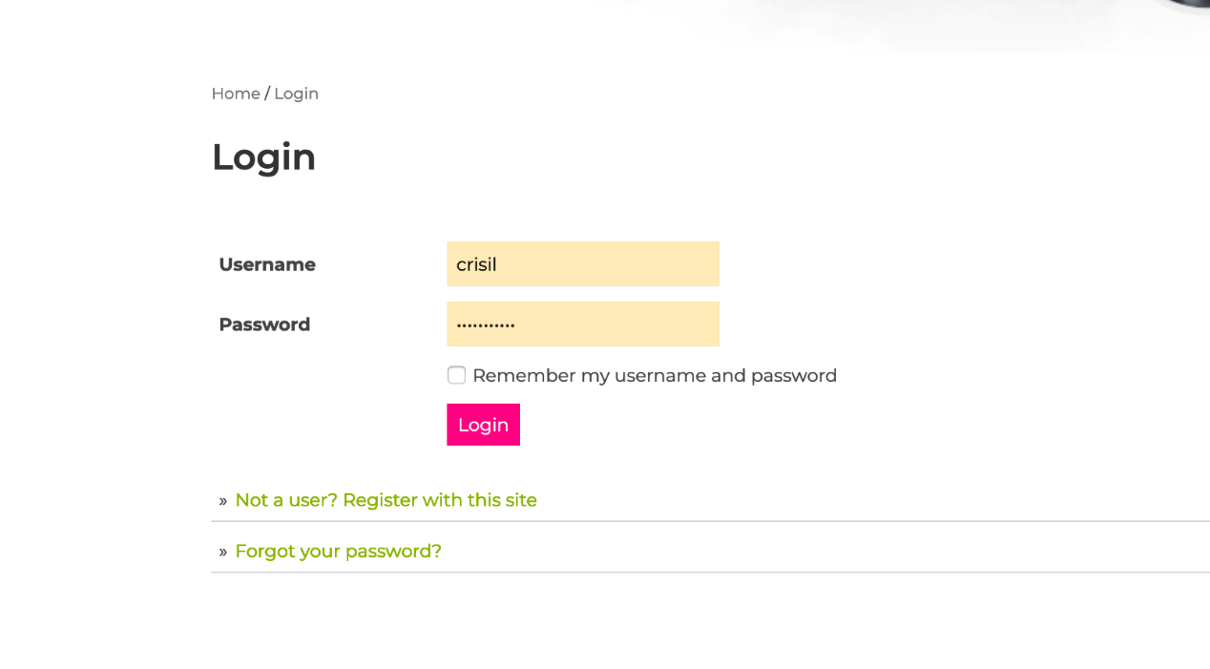

1. Check for Unassigned manuscripts:
2. 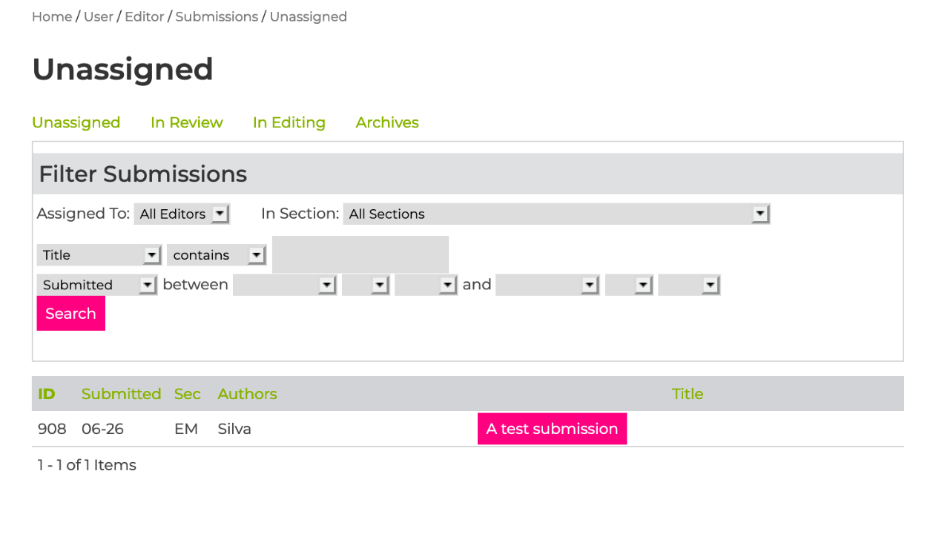Select manuscript to analyse:
3. 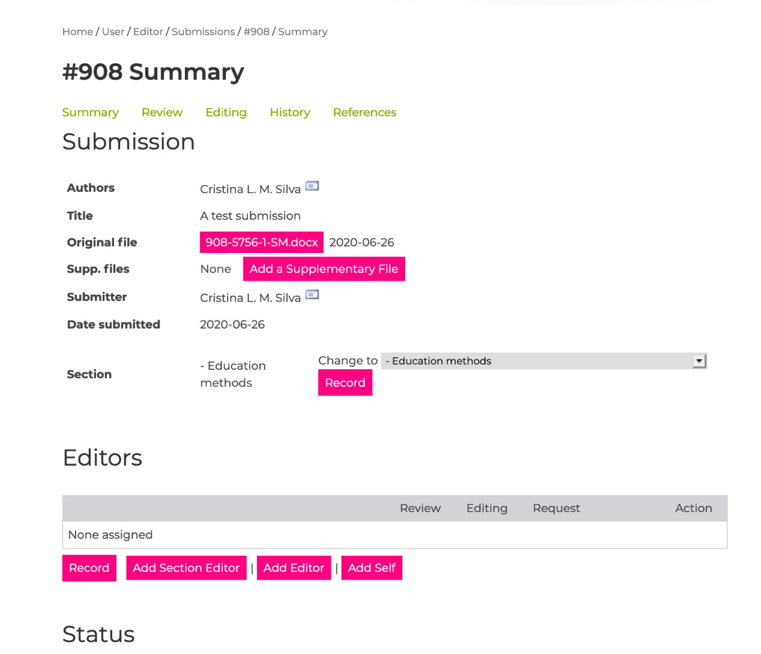Open the submission (Figure 1, (1)):

And analyse (Figure 1, (2)):

* IJFS Scope
* Scientific quality
* Language and grammar
* Plagiarism

1. Assign Associate Editor (Section Editor) if the manuscript is in conditions to enter a peer-review process (Figure 1, (3)):



1. Select the Associate Editor with expertise on the topic of the manuscript (Figure 1, (4)):



# **EDITOR PEER REVIEW**

## ***INSTRUCTIONS FOR ASSOCIATE EDITOR***

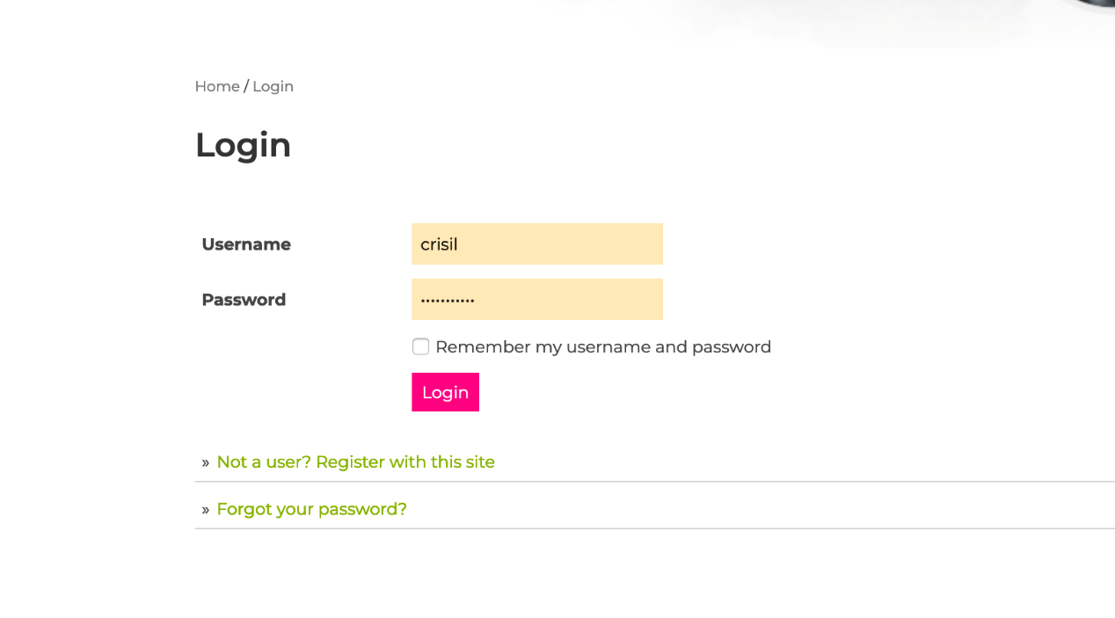1. login: <https://www.iseki-food-ejournal.com/ojs/index.php/e-journal/login>

2. Check for new manuscripts in Review:

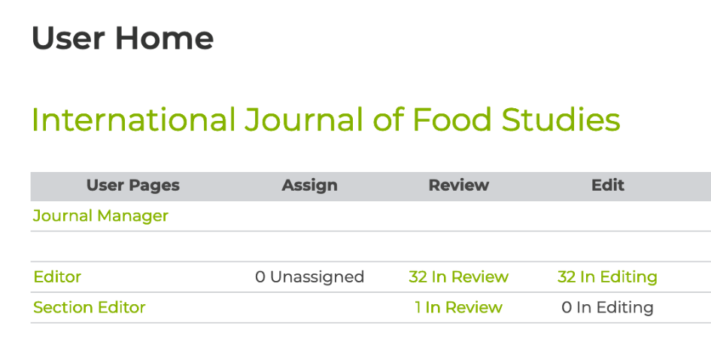

3. Select new manuscript to analyse:

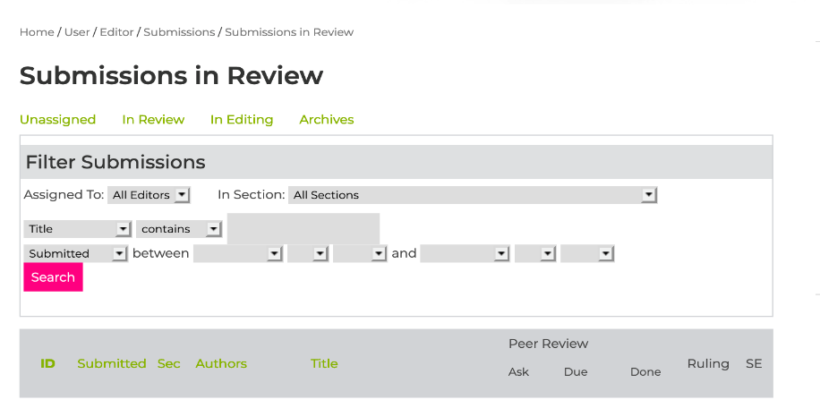

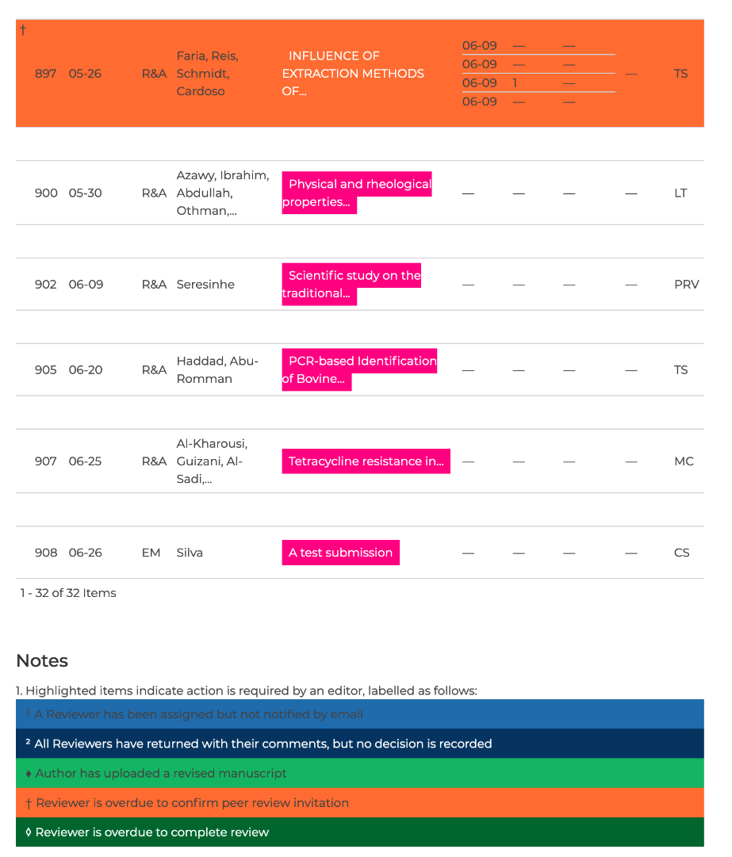

4. Open the new manuscript:

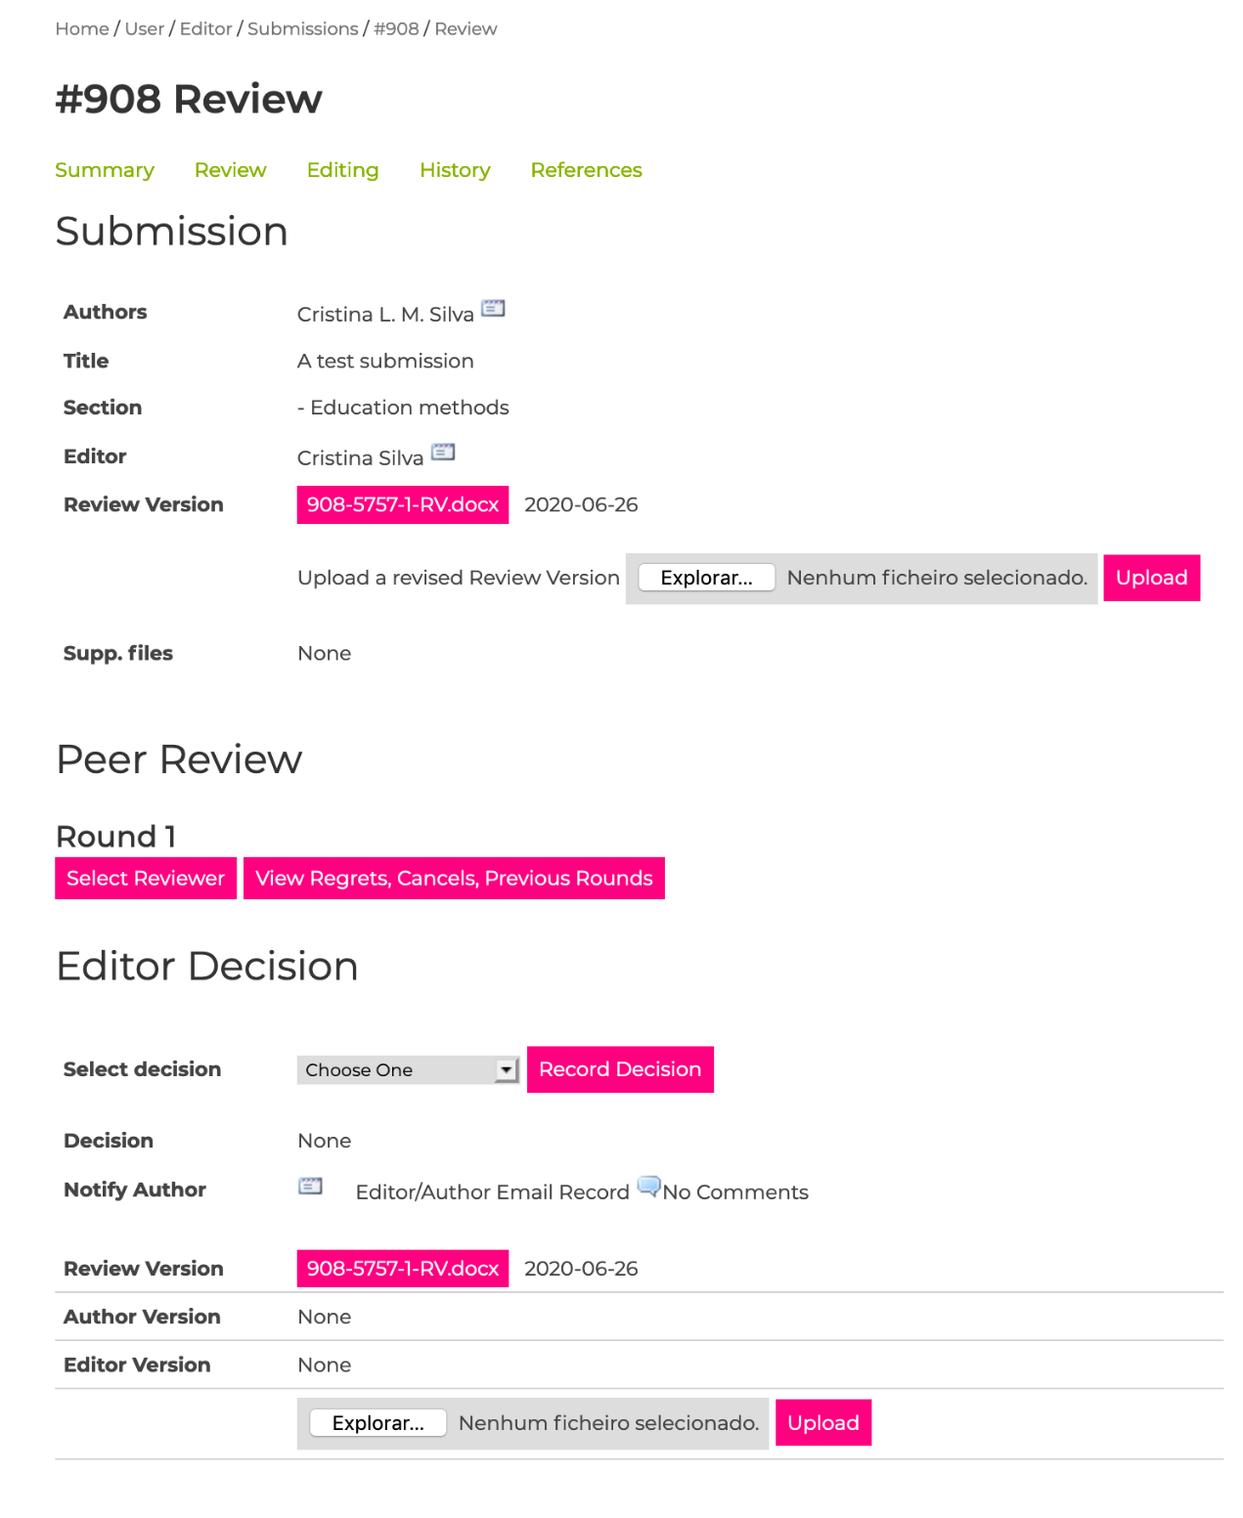

5. Confirm that you feel competent to handle the manuscript. If not, please contact the Editor-in-Chief and return the manuscript to be assigned to another Associate Editor.

**STARTING of Peer Review Round 1.**

1. Analyse the scientific quality of the manuscript and select at least two reviewers (Figure 1, (5)): 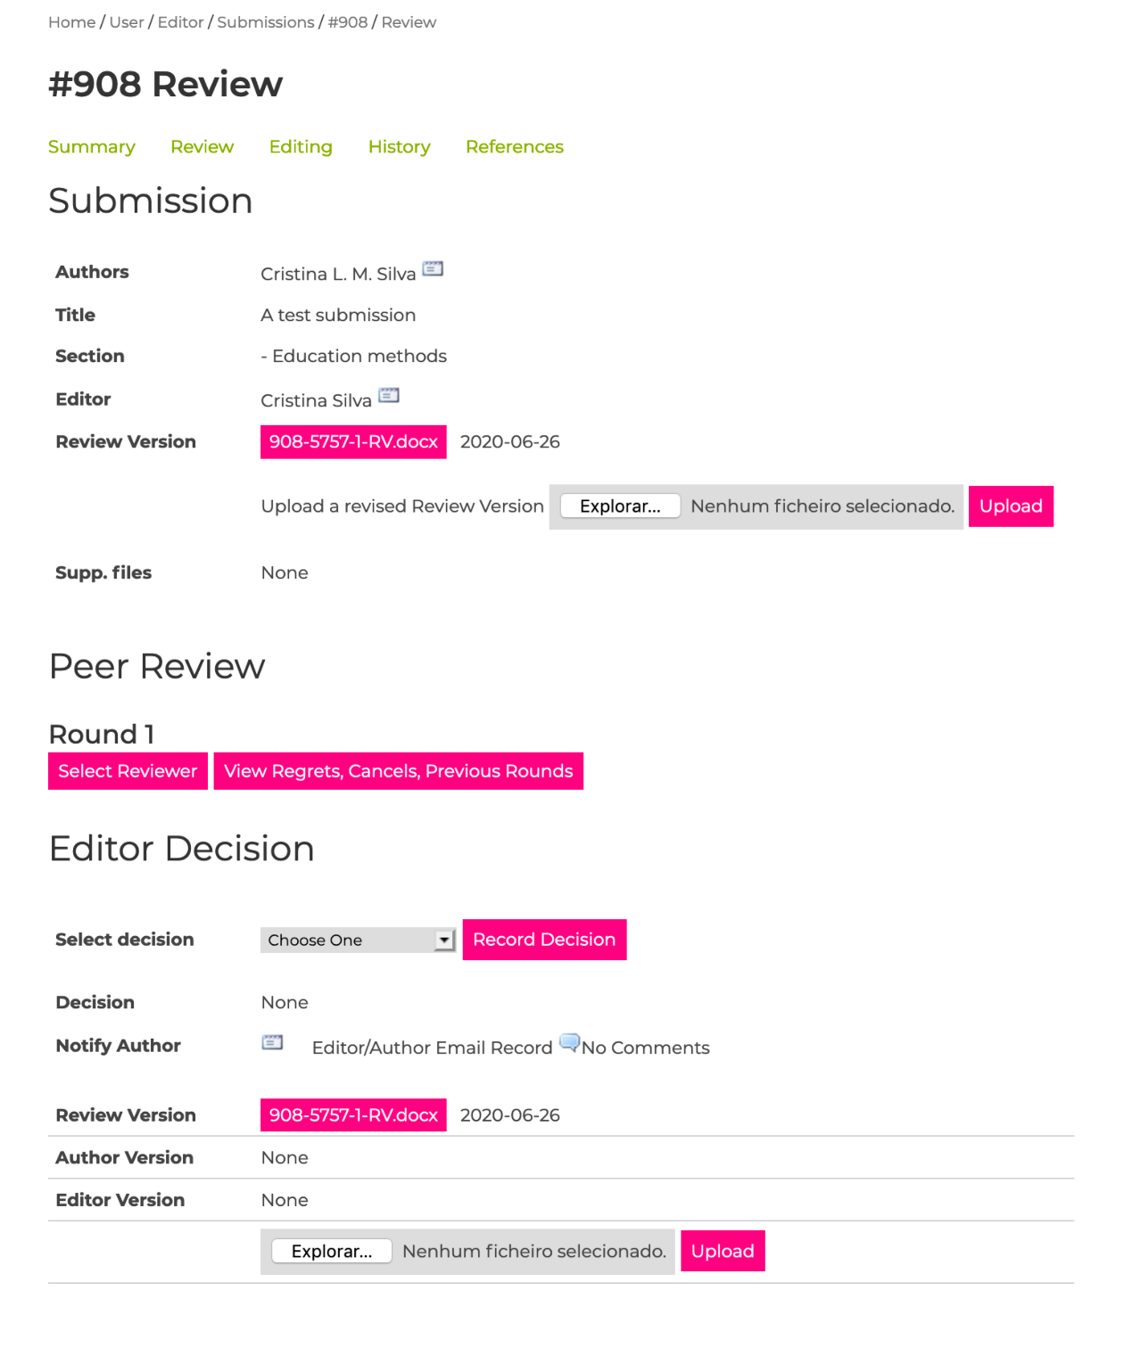
2. Select from the list of IJFS reviewers:

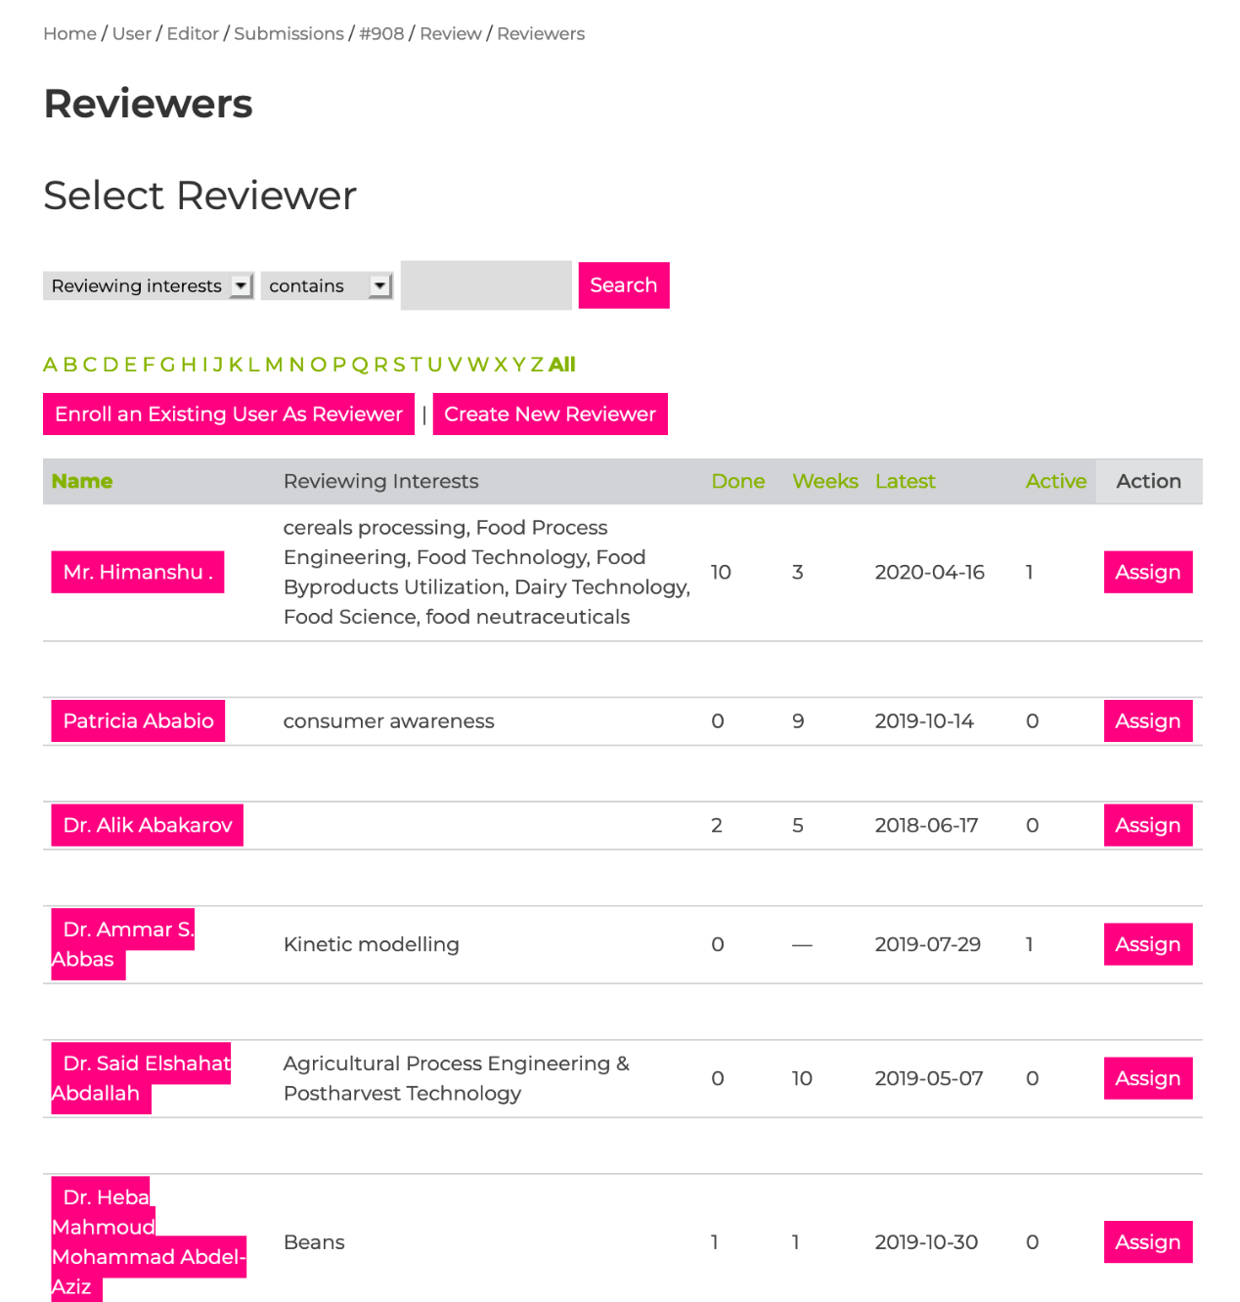

On top of the page it is possible to search by name, email or reviewer interests.

1. Or enroll existing user

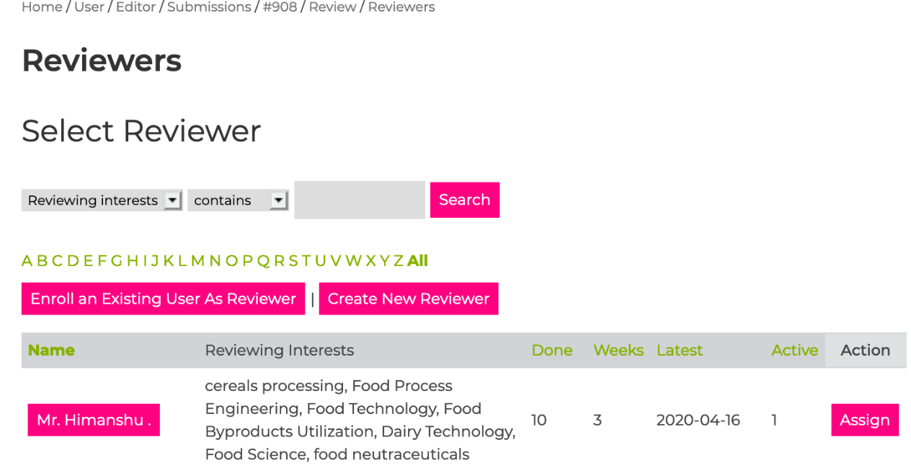

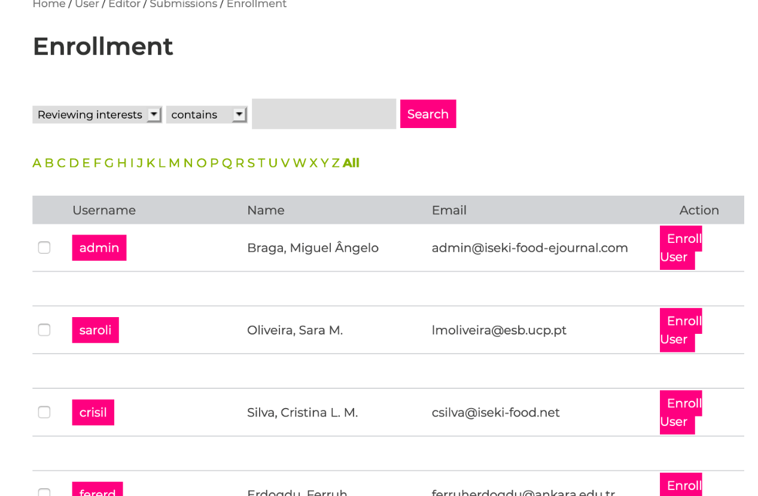

1. Or invite new experts to collaborate with IJFS as reviewers: 

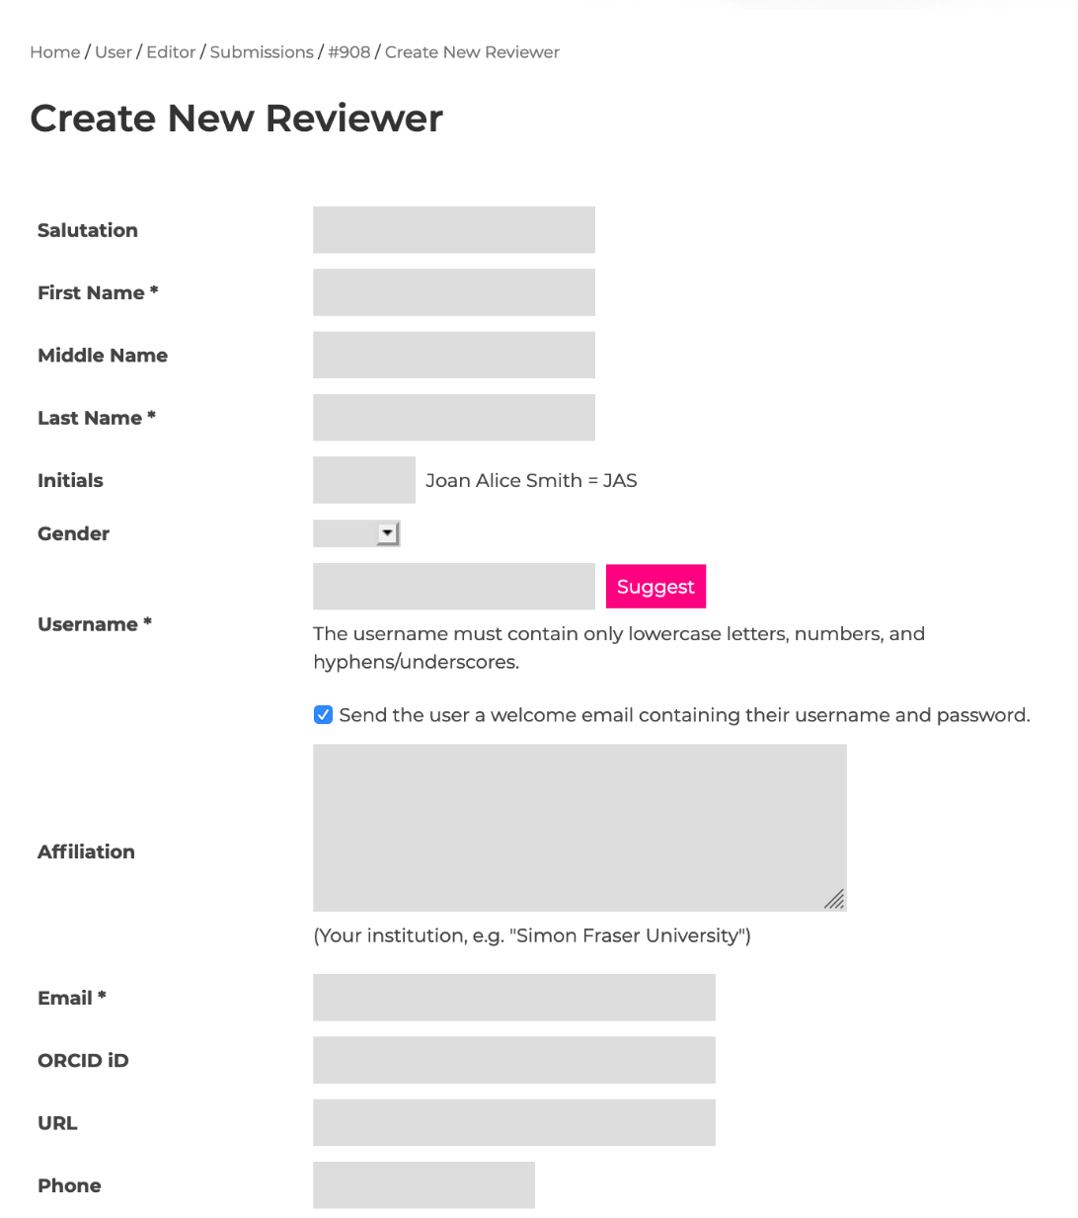

1. Request the reviewer:

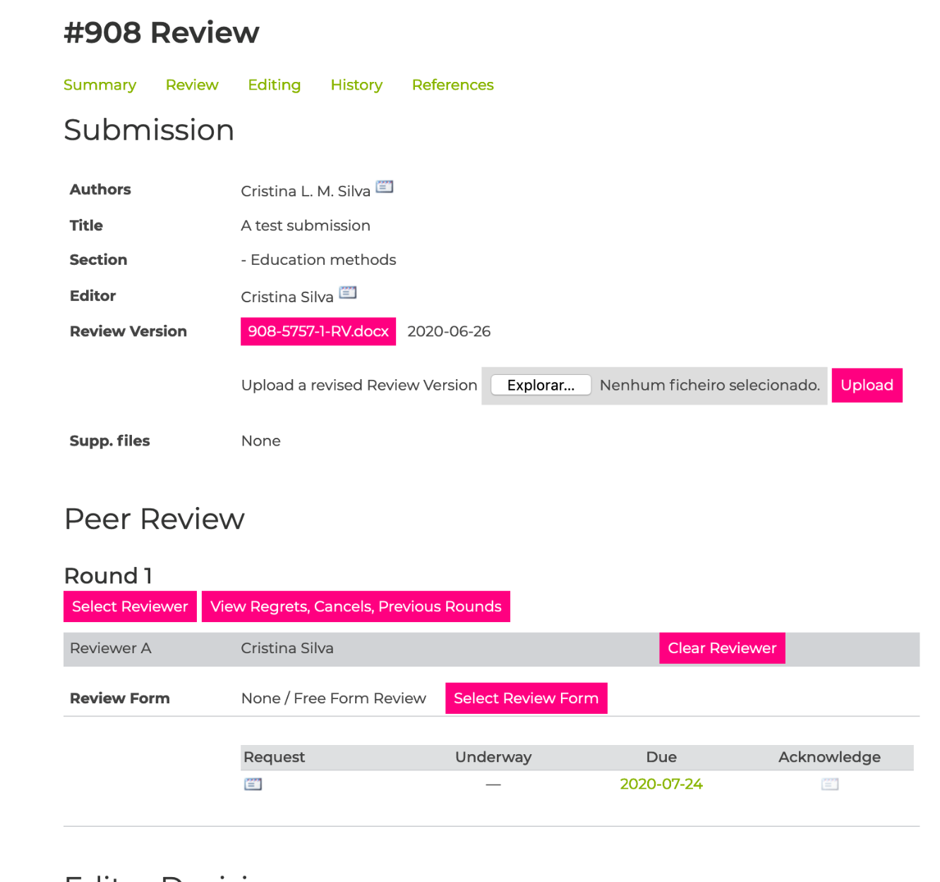

1. and send email – You can edit the message and define the time for the reviewer to return his/her comments 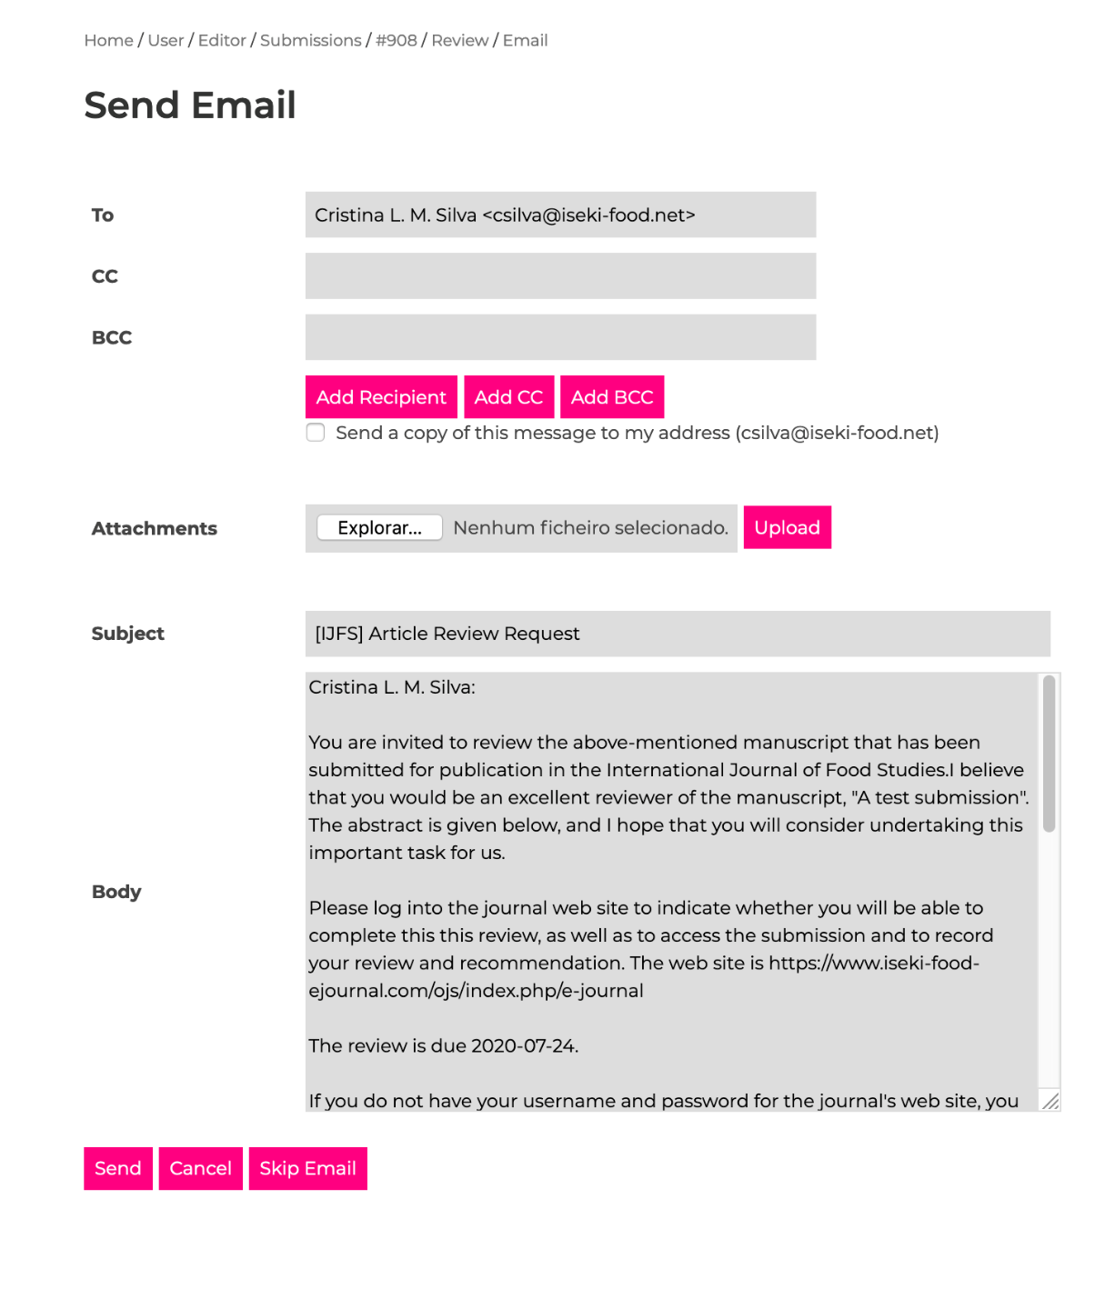
2. Check regularly the answers of the reviewers – the IJFS does not have automatic reminders:

Check if the reviewer accepted to do the review

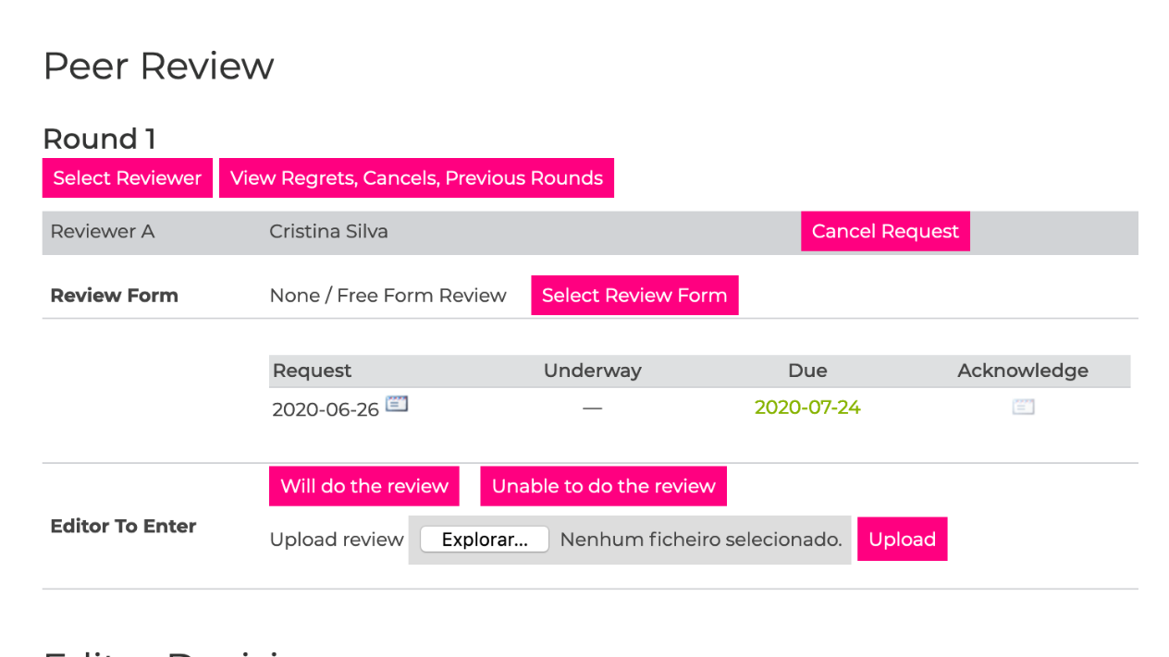

1. Colour in the main menu indicate the status of the manuscripts:

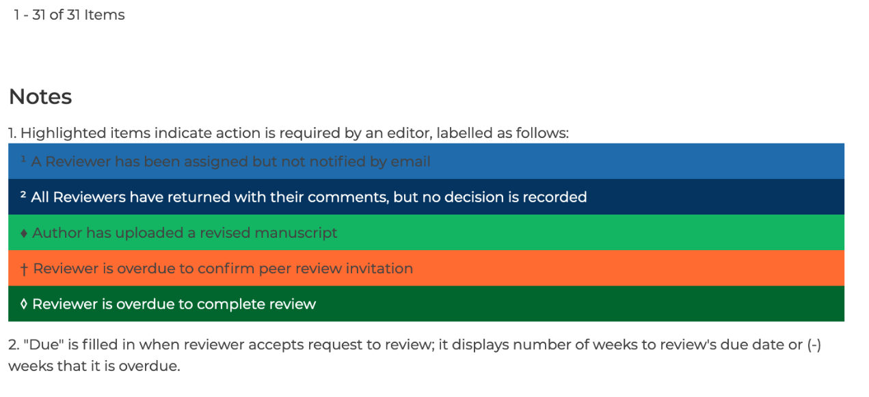

1. Analyse reviewers’ comments (at least two revisions are required to make a decision) (Figure 1, (6)):

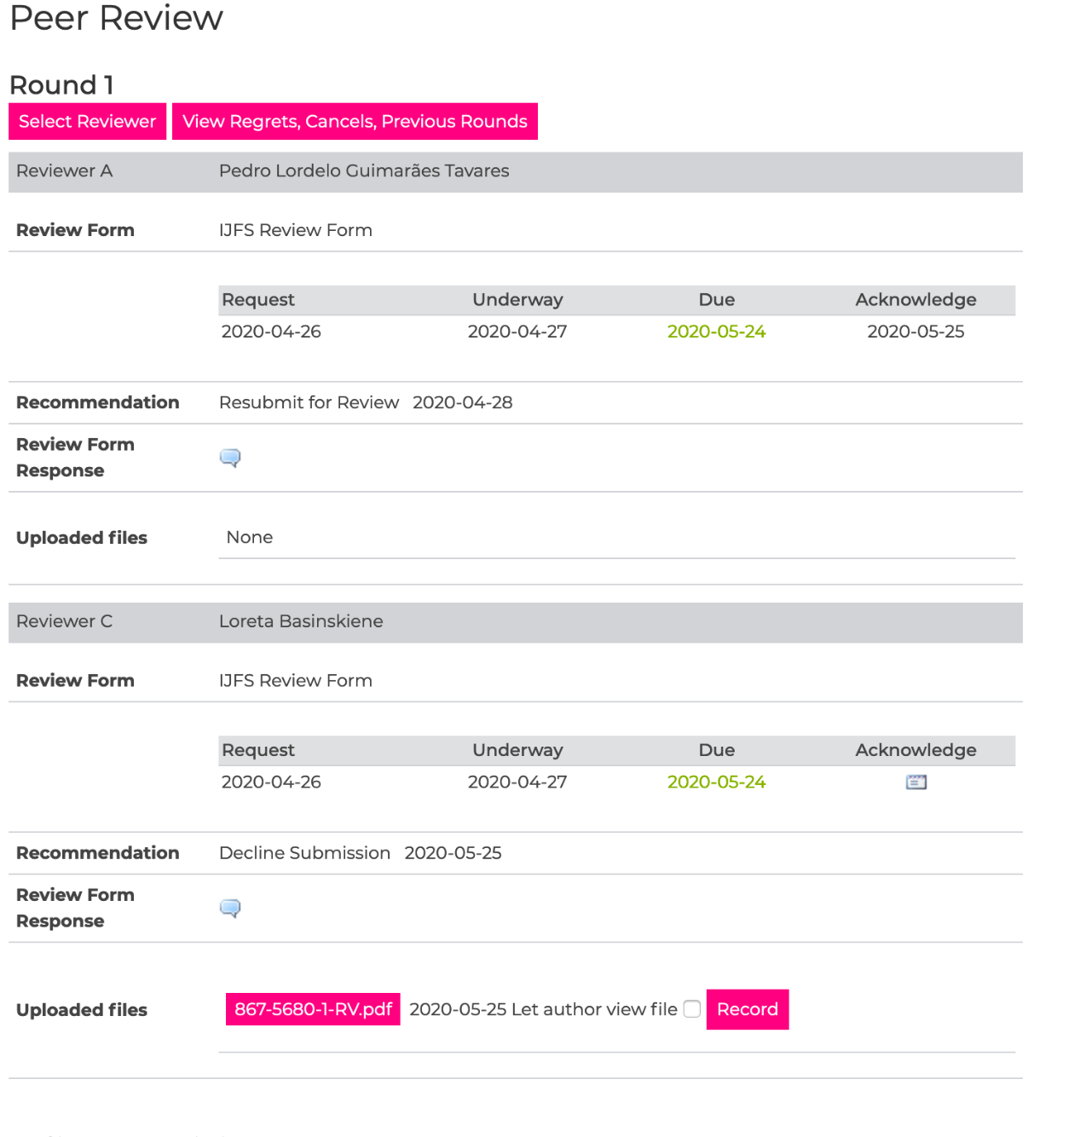

1. Acknowledge the reviewer



1. Take a decision on the manuscript: select from the menu and upload comments to the authors.

You should prepare a file combining all the suggestions and recommendations to the author, or justification for declining.

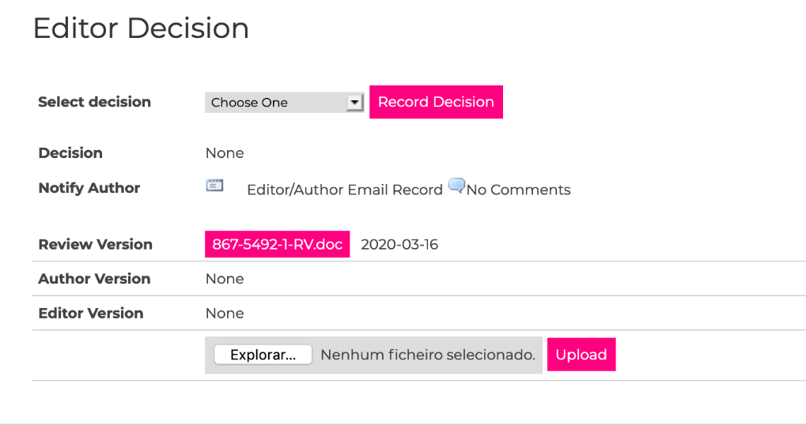

1. Notify the authors (Figure 1, (7)):

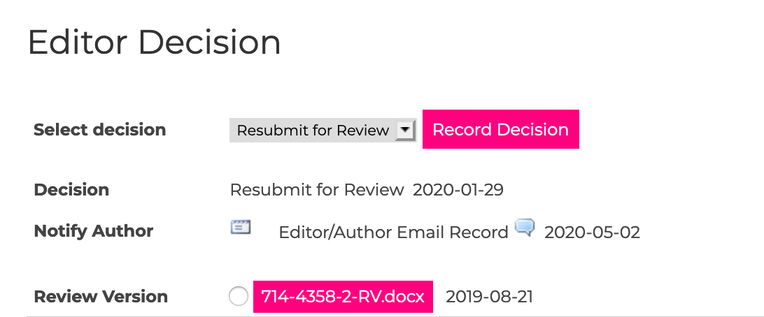

According to the quality of the manuscript and the authors revision, there can be several rounds of peer review. Then, after the first peer review (Round 1), the Associate Editor (Figure 1, (7)) can accept the manuscript, rejected it, or return it to the authors again to start a second peer review (Round 2) (Figure 1, (8)).

**After Authors return revised manuscript – analyse and decide if it is necessary to start a Peer Review Round 2 or if it can be accepted.**

1. Start a Peer Review Round 2 (Figure 1, (9)) and follow similar procedure till the new decision (Figure 1, (12)):

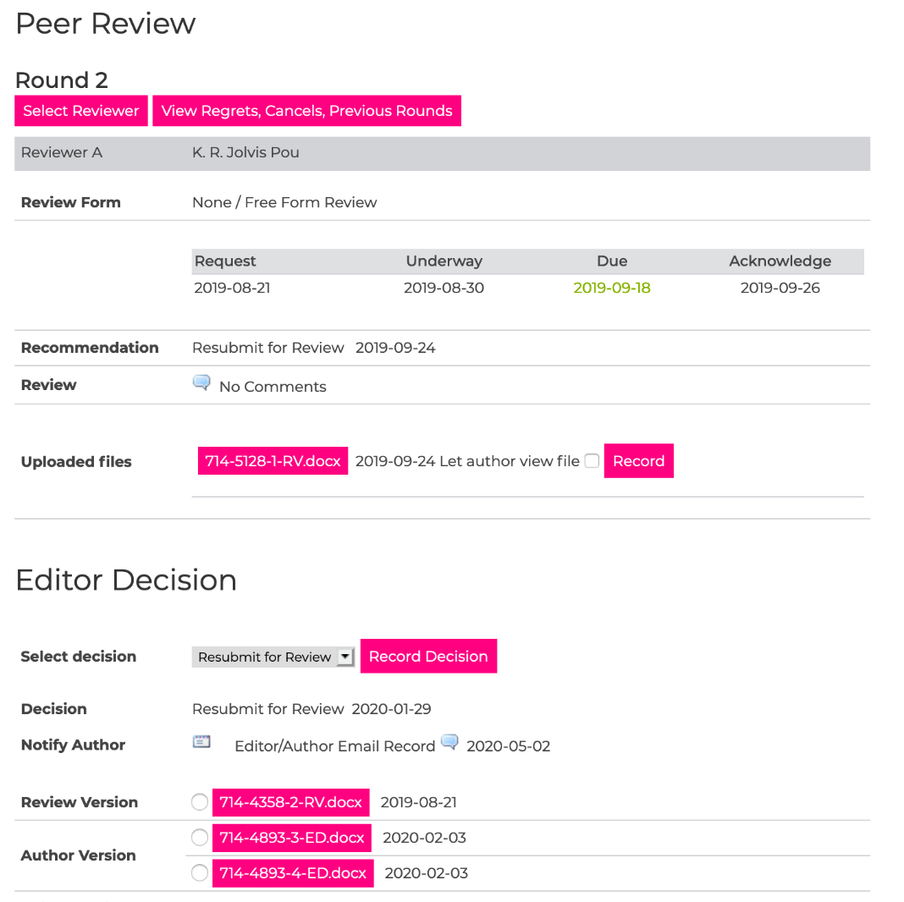

19. Manuscript is in conditions to be accepted (Figure 1, (13)):

Select the decision, notify the authors, upload a clean final version and send for copyediting

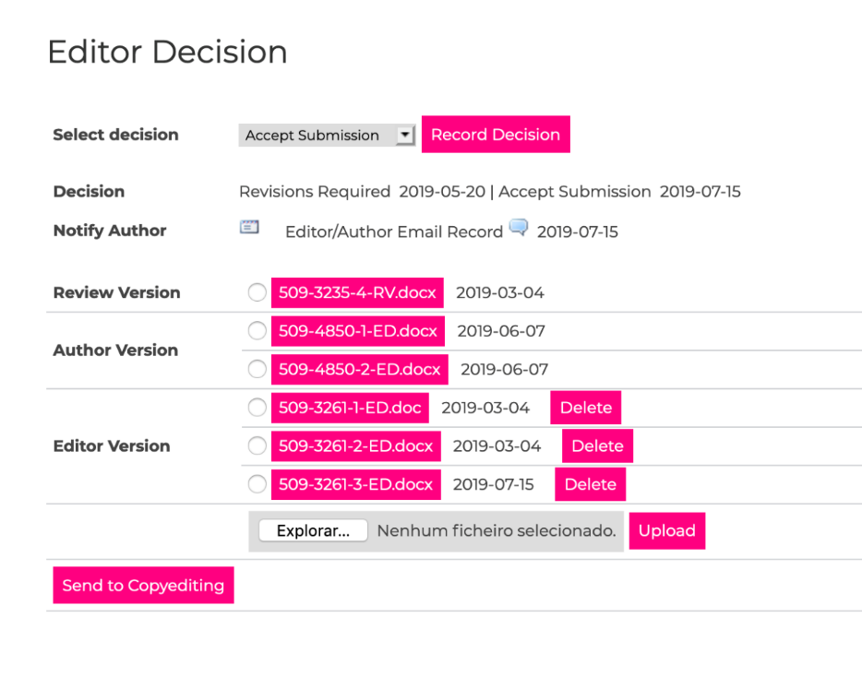

1. The manuscript is then taken care by the copyeditors and Layout Editors teams.